Goal Setting Processes

How much is there to setting goals can there really be? It is an interesting question, and one that needs to be answered.
How often do you hear someone state they have a goal, but it is not clearly defined? Your ear may not be as tuned to it as you might think, for in most cases we accept the basic statement of a want, need, or desire as a goal. They are not! Those are wants, needs, and desires, and they are perfectly fine to have, but they are not goals until they have met certain requirements, which is why we discuss the idea of proper goal setting at all.
When you ask them what their goals are they say, I want a new car. Or they state they want to put their children through college, or retire at the age of 55. These are examples of wants, needs, or desires.
They require little thought. They are nice, no doubt all of these are fine ideas, but they are not yet turned into goals.

Properly Set Goals meet these requirements:
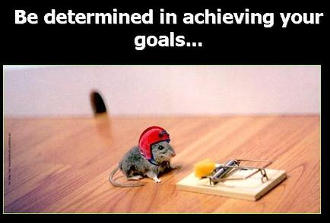

- They are Measurable& Specific
- They have a definite Timetable
- They are Understandable by all
- They are Attainable
- They are Realistic
- They are Worthy and Moral

As you can see, the listing of ideas above about retiring at age 55, the new car, and college for the children are the beginnings of what make up a good goal.

Properly constructed goals are the responsibility of leadership,
and lead to improved accountability!

Here is the fundamental issue:

- As business owners we accept poorly constructed goals by our employees.
- This in turn leads to poor or no accountability!
- Poor accountability almost always leads to less than desirable results.
It starts and ends with your leadership acceptance of what a properly set goal is within your company.

Do you set goals in your company?
Do your employees participate in the process?
Do your employees know what constitutes a properly established goal?

These are some valid questions for you to think about, for rarely do we see a company leadership team that is focused on the proper method for setting goals within the company.

Proper Goal Setting Takes Effort!

Step 1. Define the company goals in the planning process. Having the company goals established first makes the departmental goals, and individual goals flow directly to the company goals.
Step 2. Ask the employees to consider what their departmental goals should be, and their individual goals knowing the main company goals.
Step 3. Likely you will get back ideas, needs, wants, desires, but not well constructed goals. Your job as a leader is to not accept these, and to train your personnel on what you expect, which is a properly constructed well thought-out goal.
Step 4. Work with them individually and as a team to establish the framework for the goals to be created.
Step 5. Use the acid test for what makes a properly constructed goal (SMART).
Step 6. Construct the departmental and individual goals based on the acid test, and the company goals – which of course are aligned with the company vision, mission, core values, and operating philosophies.

Example of a Properly Set Goal:
I will be capable of retiring by the age of 55, by having 20 million in liquid savings,
2 million by age 35, 10 million by age 50, and 20 million by age 55.

Check the acid test above – Specific, measurable, attainable, timetable, understandable, realistic, worthy and moral. The goal checks out.

How do we implement a goal setting process that works?

- No longer accept flawed goal setting and be aware of good goal process.
- Set departmental goals, focus on the individual business segment, and align departmental goals in the company with your business plan goals.
- Work with your personnel on their goal setting to meet the acid test. Coach them using the goal setting tools
- Be sure to accept only properly constructed goals when they are final, and tie them to compensation and rewards.
- Any good goal setting process also contains a feedback and review process to check milestones. We use weekly, monthly, quarterly.
- Have regular communication and public goal boards to discuss results, and also review success stories, communicating the results.

Why is this Critical to Your Success?

- Proper goal setting focuses people and employees on the key issues.
- Proper goal setting process creates accountability for results and eliminates wiggle room for excuses.
- Good goal setting makes a leaders’ job easier, and will improve Profits!

