Step by Step to Understanding & Implementing
The Dual Overhead Pricing Method
Dual overhead is considered by some to be a complicated system of pricing, when really it is very simple. If you are used to using the Divisor method, or multiplier method, you will find the dual overhead method different than the others, and you may also find it produces a more accurate price for the products and services we provide in contracting.
Dual overhead uses the premise that labor hours or a company use of labor drives overhead expenses, meaning the more labor hours used, the more overhead will rise. In contracting, this is a valid assumption and has merit for your consideration.
The dual overhead pricing method does require a company to have a strong financial framework in order to be certain the figures used in the dual overhead calculations are up-to-date and accurate.
How does dual overhead work?
Dual overhead pricing uses the company’s overhead to create two factors used in setting price.
- The 1st factor is what is called a Materials factor (from our materials/equipment and non-labor costs).
- The 2nd factor is what is called a Labor Factor (from our labor costs).
The two factors are created from the company’s financial operating characteristics. We will use the historical records of the company so we have a broad view of the costs, and do not get caught-up in a short window of cost variations.
The dual overhead system is based on the direct cost of sales for the financial information. These are once again defined as direct costs only and look like this for the industry standards:
Revenues:
Direct Labor
Direct Labor Benefits
Warranty Reserve
Subcontract Expenses
Direct Cost of Sales
Job Start-up Labor (typically commercial only)
Materials & Parts
Equipment
Sales Commissions
Permits

So we will use the totals of (Materials / Parts/ Equipment / Subcontractors / Permits) for the materials factor and the (Direct Labor / Warranty Labor / Labor for Start-Up /Direct Labor Benefits) for the labor factor.
No two companies would end up with the same factors, because like people, all companies have different overhead rates, different labor costs, and would bid jobs differently.
What is important to understand is that your company factors are the only factors that matter, and so long as you run an efficient company, the system will work for you.
What is important to understand is that your company factors are the only factors that matter, and so long as you run an efficient company, the system will work for you.

How do I calculate a price using the dual overhead method?

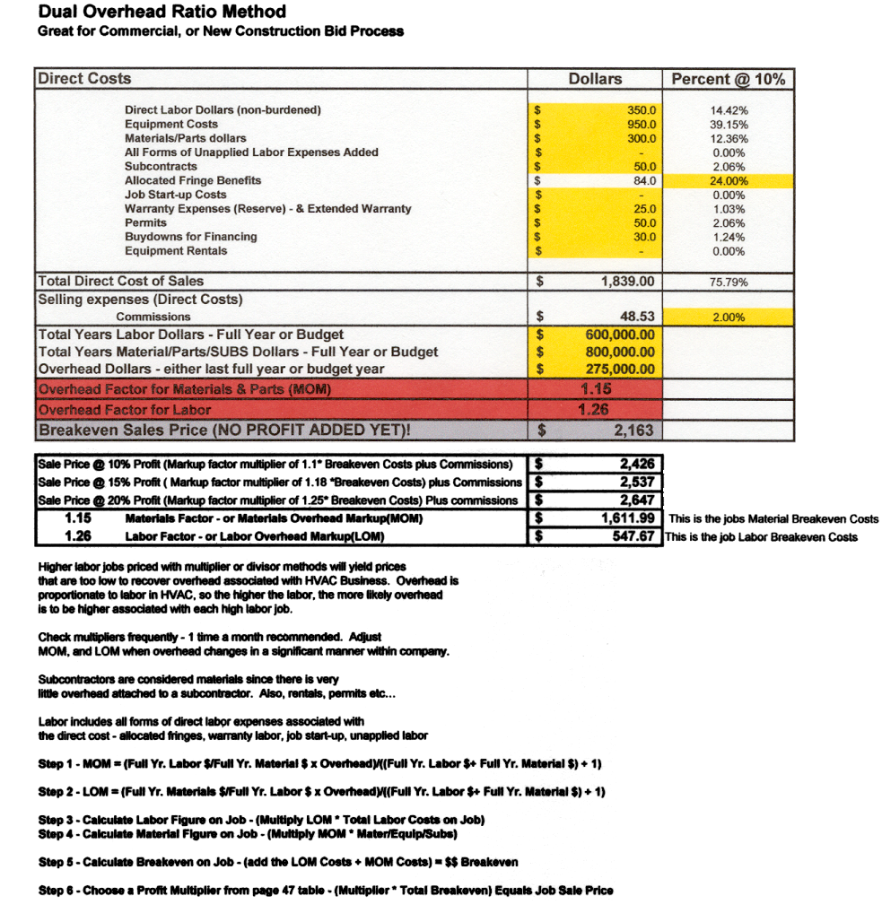

The dual overhead formulas are as follows:
Higher labor jobs priced with multiplier or divisor methods will yield prices, which are too low to recover overhead associated with HVAC Business. Overhead is proportionate to labor hours/dollars in contracting so the higher the labor, the more likely overhead is to be higher associated with each high labor job.
Check multipliers frequently - 1 time a month recommended. Adjust MOM, and LOM when overhead changes in a significant manner within company.
Subcontractors are considered materials since there is very little overhead attached to a subcontractor. Also rentals permits etc.
Labor includes all forms of direct labor expenses associated with the direct cost - allocated fringes, warranty labor, job start-up, and unapplied labor.
Step 1: MOM = (Full Yr. Labor $/Full Yr. Material $ x Overhead) / (Full Yr. Labor $+ Full Yr. Material $) + 1).
Step 2: LOM = (Full Yr. Materials $/Full Yr. Labor $ x Overhead) / (Full Yr. Labor $+ Full Yr. Material $) + 1).
Step 3: Calculate Labor Figure on Job - (Multiply LOM * Total Labor Costs on Job).
Step 4: Calculate Material Figure on Job - (Multiply MOM * Mater/Equip/Subs).
Step 5: Calculate Breakeven on Job - (Add the LOM Costs + MOM Costs) = $$ Breakeven.
Step 6: Choose a Profit Multiplier to add profit to breakeven - (Multiplier * Total Breakeven) equals job sale price.
How do I use dual overhead to my benefit?
Dual overhead allows you accuracy to bid jobs that are closely related to how we as contractors perform our work. Meaning when you run into a highly labor intensive job, dual overhead factors in the idea that more labor means more future overhead, so we better get paid to cover that fact.
It also works the opposite way, that when you run into a high material low labor job, dual overhead it going to yield prices that is more competitive in your market.
Remember your company overhead is not static. Labor hours in our direct costs can and do drive-up variable costs, such as vehicle expense, gasoline expense, small tools wear and tear, uniform expense, training, even the more hours we use in direct labor the higher the risk for a workers compensation claim (just look at how insurance companies set the workers compensation premiums – Payroll costs).
Also a key point to make referring back to pricing strategy and that is we always price to market and accept what the market will bear, even though we may have the ability with our company efficiency to be less than that market price. At least you know where you could be if you needed to be from a negotiating standpoint.
Why would I switch to dual overhead?
- There are a few reasons why. No matter what market segment you are pricing for, dual overhead is the most accurate method of arriving at a price based on your company financial characteristics.
- Dual Overhead gives you the peace of mind of knowing where your breakeven is, and the ability to know how much profit you are making at a given price point. You decide how competitive you want to be.
A company that is fully departmentalized in the profit and loss statement, so as to know the overhead dollars in new construction, commercial construction, and all other areas of the company, dual overhead offers a third reason.
- The accuracy of allocated departmental overhead gives the company maximum competitive advantage in the market to determine breakeven price, and choose how close to breakeven they want to be if they need to be.
To better understand how dual overhead compares to other methods:
Go ahead, blow them up and see the message. This is how dual overhead compares to other price methods. They all work fine. Each will produce a price. Some methods simply let you see things that other methods do not. Dual overhead gives you a price that is far more representative of what your company looks like operationally. The financial numbers are your company numbers, and the job figures are your estimates, so it is a highly focused, custom method to pricing, and it is the most accurate. View the EXCEL file for the comparisons side by side of the very same job costs, and see the variations in price between Divisor, Multiplier, and Dual Overhead. People will often say, "How can that be?" Look down again!

From 10 feet away you see:
From 100 feet away you see:
From 1 foot away you see:

Dual overhead pricing won’t get you any more jobs, but it can put you in a position to decide how you want to bid them due to your clarity about the costs involved on the job.
A high labor job may begin to look less attractive to you if your job board is full, or nearing full. You may elect to tender a price that is higher than normal, or if the job board is empty you may choose to price the job competitively, knowing that the margin isn’t great, but it is keeping your labor force working for you and not your competitor.
The divisor method is great because it is easy to understand. It just doesn’t take into account certain types of work matter as much as the costs of the work. Divisor doesn’t accommodate the need to price our jobs higher when the labor hours are considered to be high.
I once knew a contractor, who has since sold the business to a consolidator, and they priced their jobs the same way using the divisor method, and they did a ton of attic and duct jobs in their market, driving their mix farther and farther towards this type of work. Once day after a financial review, we discussed why dual overhead would charge a higher price, and the contractor said he might lose some of that work. He then realized he NEEDED to lose some of that work and mix in some higher margin replacement work, or raise his prices for the high labor type work. All along the contractor was underpricing the high labor work, the overhead costs kept rising, and it became a viscous circle. The more attic work he got, the less money he made at the price he was charging, because the overhead kept rising due to the longer hours it took to complete the hard attic installs. The realization that the competition was higher priced on these types of jobs, and frankly driving the work towards him finally got him to raise his prices, start using dual overhead, and start reviewing the work on the basis of how many gross profit dollars per hour it produced for the company (not many by the way compared to a replacement). He started filling the newly vacated labor hours with jobs offering higher margins, easier to complete and he made enough money to eventually sell the business!
Now I am not suggesting you get rid of attic work, or cut-in return air grille jobs. You cannot serve your customers well by focusing on your profit needs. It is quite the opposite. You can however suggest to the homeowners that you move this work to off peak seasonal times when you need the work. You can even offer a discount for this kind of trade. This allows you to capture the higher margin work when it is available, and still serve your customer’s needs.

Why is this critical to my success?
- Understanding the pricing systems of contracting make you more able to determine your own destiny.
- Making Dual Overhead part of your arsenal can help you attain more profits.
- Dual overhead can help you remain competitive at price points you may not have felt possible if you were using the divisor method, or the margin-markup method.
- Dual overhead allows you to identify breakeven easily on each job, allowing you to know job-by-job how to use pricing strategy, if you choose too!

