**ABC Heating & A/C**

**Residential Job Survey Form**

Customer Information

Date Sold:

Customer Name:

Street:

City, State, Zip:

Home Phone:

Work Phone:

Special Instructions:

Financial Information

Salesman:

Selling Price:

Billable: Financing: HRSI: Other:

COD: _____ Deposit: _____ Balance Due: _______

Job Information

Job Number:

Job Contracted:

Installation Date:

Mechanic:

Hours Allocated:

Permit Taken: Yes No $ _______________________

Mailed in Walked In

Extended Warranty

One Year Parts and Labor

2nd thru 5th Year Parts and Labor

2nd thru 5th Year Parts Only

6th thru 10th Year Compressor Warranty

11th thru 20th Year Extended Heat Exchanger

2nd thru 10th Year Parts Only on Variables

A.C. FUR CZ E.A.C. HUM

A.C. Warranty Starts at Sprint Start-Up

____Years on Boiler Sections

|  |  |  |  |  |  |
| --- | --- | --- | --- | --- | --- |
| **Brand** | **Equipment** | **Model** | **Serial Number** | **Qty** | **Cost** |
|  | **Condenser** |  |  |  |  |
|  | **Coil/ Fan Section** |  |  |  |  |
|  | **Furnace Or Boiler** |  |  |  |  |
|  | **Chimney Liner** |  |  |  |  |
|  | **Air Cleaner** |  |  |  |  |
|  | **Humidifier** |  |  |  |  |
|  | **N.S.B. Stat** |  |  |  |  |
|  | **Hot Water Tank** |  |  |  |  |
|  |  |  |  |  |  |
|  |  |  |  |  |  |
|  |  |  |  |  |  |
|  |  |  |  |  |  |

T.E.C. _____ T.M._____ T.J.C._______

Installation Instructions

|  |  |  |  |
| --- | --- | --- | --- |
| **Heating** | | **Air Condition** | |
|  | Conc. Blocks |  | Pad |
|  | Used Existing Base |  | Used Existing Pad |
|  | Forced Air |  | Heat Pump Stand |
|  | Gravity |  | Reinstall Existing (verify location with compressor customer) |
|  | Location |  |  |

|  |  |  |  |
| --- | --- | --- | --- |
| **Air Cleaner** | | **Humidifier** | |
|  | Reinstall Existing |  | Reinstall Existing |
|  | Install Accordingly |  | Install Accordingly |
|  | Filter Rack |  | Hemostat On |
|  |  |  | C.A.R. |
|  |  |  | Living Area |

|  |  |  |  |
| --- | --- | --- | --- |
| **Blower Mtr** | | **Thermostat Location** | |
|  | Change To |  | Reinstalling Existing |
|  | D.D. |  | Change To |
|  | B.D. |  | Sub Base |
|  | H.P. |  | Relocate |
|  |  |  | Are to be Relocated |

|  |  |  |  |
| --- | --- | --- | --- |
| **Drains** | | **Sheet Metal** | |
|  | ABS Length |  | Plenum Adapt |
|  | Condensate Pump |  | New Plenum |
|  | Reconnect into Existing |  | Return Air Adapt |
|  | Kick Plate |  | New Return Air Drop |
|  |  |  | Panning |
|  |  |  | Ft. |
|  |  |  | Runs |
|  |  |  | No |
|  |  |  | Inch |
|  |  |  | Ext. Truck |
| **Ref. Lines Size** | | **Electrical** | |
|  | SUC |  | Glass Fuses |
|  | Liquid |  | Breakers |
|  | Length |  | Has Room on Buss |
|  | Use Existing |  | Add Sub Panel |
|  | Add Filter Drier |  | Add New Panel |
|  |  |  | Length of Electrical |
|  |  |  | CEI Contacted |
|  |  |  | Existing Electrical |
|  |  |  | New Disconnect |

**Remarks:**

|  |  |  |
| --- | --- | --- |
| **Water Heater Drafthood** | **Maximum clay this liner** | **Maximum type "b" vent** |
| **Attached hood** | **Outside dimensions** | **Inside dimensions** |
| **3"** | **8" X 8"** | **7"** |
|  |  | **6** |
| **4" - 6"** | **12" X 12"** | **10"** |

|  |  |  |  |
| --- | --- | --- | --- |
| **Normal liner size inches** | **Inside dimensions in liner inches** | **Inside dia. Or equivalent dia. Inches** | **Equivalent area sq. Inches** |
| **4 X 8** | **2 1/2 X 6 1/2** | **4** | **12.2** |
|  |  | **5** | **19.6** |
|  |  | **6** | **26.3** |
|  |  | **7** | **38.3** |
| **8 X 8** | **6 3/4 X 6 3/4** |  | **42.7** |
|  |  | **8** | **58.3** |
| **8 X 12** | **6 1/2 X 10 1/2** | **9** | **63.6** |
|  |  | **10** | **78.5** |
| **12 X 12** | **9 3/4 X 9 3/4** |  | **83.3** |

If the chimney does not have a liner it must be brought up to code a fan assisted furnace must be common vented with a natural draft appliance to utilize a clay tile lined chimney.

Never change the draft hood on the water heater. You assume any liability if you change the draft hood.

In most cases the vent connector must be upsized on the water heater. Don’t be surprised when you have to install a 4” vent connector on a 3” draft hood-equipped water heater.

Maximum chimney size determined notes 19a & b in gamma tables.

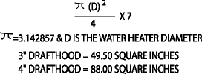

Type-b vent provides 7 – 11 degrees of heat retention per linear /ft. when compared to single wall vent connectors.

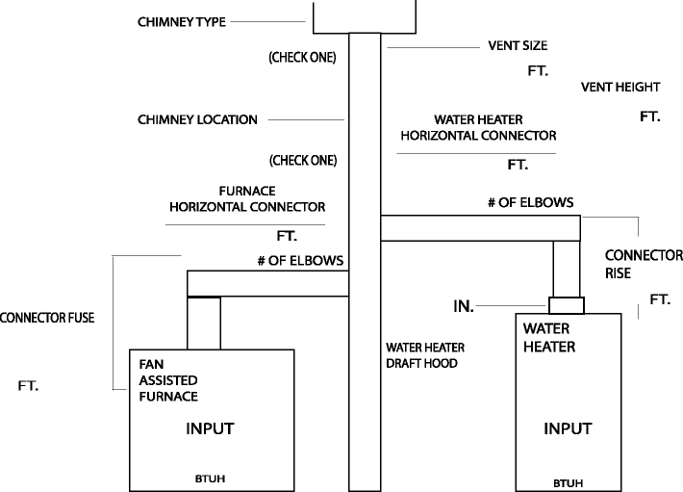

**B-VENT**

**FLEX LINER**

**MAS. CHIM**

**INSIDE** **OUTSIDE**

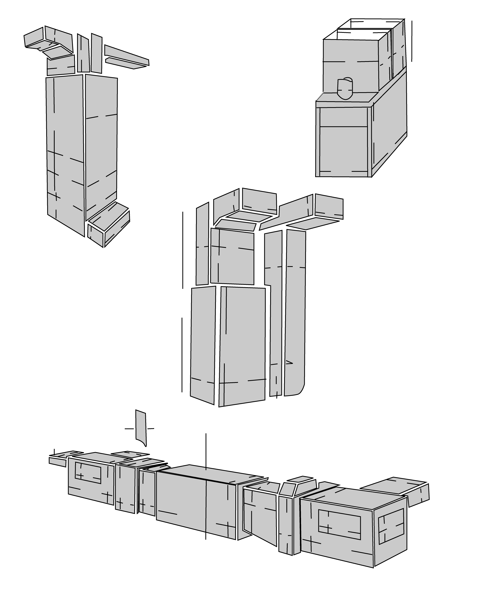

**Separation Between W/A & R/A**

**Lowboy**

**Floor to Ceiling**

**Down Flow Furnace**

**Air Handler**

**Floor to Ceiling**

**Up-flow Furnace**

**Air Handler**

**Return Drop**

**Left Side**

**Right Side**

**Height Available**

**Duct Size Out of Back**

**Duct Size Out of Side**

**Floor to Ceiling**

**Horizontal Furnace**

**Air Handler**

|  |  |  |  |  |  |  |  |
| --- | --- | --- | --- | --- | --- | --- | --- |
| **Day** | **Date** | **Hours** | **Day** | **Date** | **Hours** | **(A X B = C)** |  |
| **M****onday** |  |  | **Thursday** |  |  | **A=Total Hours** |  |
| **T****uesday** |  |  | **Friday** |  |  | **B=Labor Wage** |  |
| **W****ednesday** |  |  | **Saturday** |  |  | **C=Total Labor Cost** |  |



|  |  |  |  |  |  |
| --- | --- | --- | --- | --- | --- |
| **Heating** |  |  | **Air Conditioner** |  |  |
|  | **Yes** | **No** |  | **Yes** | **No** |
| Is sticker on equipment? |  |  | Does unit require a start-up? |  |  |
| Is working area clean? |  |  | In the spring? |  |  |
| Is power to unit on? |  |  | Is sticker on equipment? |  |  |
| Is thermostat level? |  |  | Is working area clean? |  |  |
| Is heat anticipator set properly? |  |  | Is thermostat level? |  |  |
| Has furnace operated one cycle? |  |  | Is customer satisfied with location? |  |  |
| Is all ductwork sealed? |  |  | Of condensing unit? |  |  |
| Are all runs wide open? |  |  | Is new filter installed? |  |  |
| Check airflow thru registers? |  |  | Are refrigerant lines sealed? |  |  |
| Is the job complete? |  |  | Where they exit the house? |  |  |
| Are there any damages? |  |  | Are there any damages? |  |  |
| Is flue cemented? |  |  | Is condenser level? |  |  |
| Are serial numbers on survey sheet? |  |  | Are serial numbers on survey sheet? |  |  |
| Did salesman visit jobsite? |  |  | Did salesman visit jobsite? |  |  |
| If c.o.d. did you collect? |  |  | If c.o.d. did you collect? |  |  |
| Is there more than one furnace? |  |  | Is there more than one condenser? |  |  |
| Did you contact the inspector? |  |  | Did you contact the inspector? |  |  |

**Installer’s signature:**

**Comments:**

**If C.O.D. please collect: $**

|  |  |  |  |  |  |  |  |
| --- | --- | --- | --- | --- | --- | --- | --- |
| **QTY** | **PROD/CODE** | **DESCRIPTION** | **TOTAL COST** | **QTY** | **PROD/CODE** | **DESCRIPTION** | **TOTAL COST** |
|  |  | **COPPER** |  |  | BLK282 | 3/4 BLACK COUPLING |  |
|  | CPR153 | ROLL 1/4 X 50' COIL |  |  | BLK354 | 3/4 BLACK 90 |  |
|  | CPR019 | ROLL 3/8 X 50' COIL |  |  | BLK355 | 3/4 BLACK ST. 90 |  |
|  | CPR142 | ROLL 1/2 X 50' COIL |  |  | BLK359 | 3/4 BLACK 45 |  |
|  | CPR588 | ROLL 3/4 X 50' COIL |  |  | BLK360 | 3/4 BLACK ST. 45 |  |
|  | CPRR08 | ROLL 7/8 X 50' COIL |  |  | BLK283 | 3/4 GAS COCK |  |
|  | CPR589 | 1 1/8 COPPER PIPE |  |  | BLK361 | 3/4 X SHORT NIPPLE |  |
|  | CPR010 | 1 1/8 COPPER 90 |  |  | BLK362 | 3/4 X CLOSE NIPPLE |  |
|  | CPR121 | 1 1/8 COPPER COUPLING |  |  | BLK363 | 3/4 X 2 BLK. NIPPLE |  |
|  | CPR082 | 7/8 COPPER COUPLING |  |  | BLK364 | 3/4 X 2 1/2 NIPPLE |  |
|  | CPR084 | 7/8 COPPER 90 |  |  | BLK300 | 3/4 X 3 BLK. NIPPLE |  |
|  | CPR541 | 3/4 COPPER COUPLING |  |  | BLK365 | 3/4 X 3 1/2 NIPPLE |  |
|  | CPR487 | 3/4 COPPER 90 |  |  | BLK366 | 3/4 X 4 BLK. NIPPLE |  |
|  | CPR340 | 5/8 COPPER COUPLING |  |  | BLK367 | 3/4 X 4 1/2 NIPPLE |  |
|  | CPRS42 | 5/8 COPPER 90 |  |  | BLK368 | 3/4 X 5 BLK. NIPPLE |  |
|  | CPR537 | 1/2 COPPER COUPLING |  |  | BLK305 | 3/4 X 5 1/2 NIPPLE |  |
|  | CPR538 | 1/2 COPPER 90 |  |  | BLK369 | 3/4 X 6 BLK. NIPPLE |  |
|  | CPR539 | 3/8 COPPER COUPLING |  |  | BLK125 | 1" BLACK PIPE PER FT. |  |
|  | CPR540 | 3/8 COPPER 90 |  |  | BLK134 | 1" BLACK UNION |  |
|  | CPR346 | 1/4 COPPER COUPLING |  |  | BLK133 | 1" BLACK TEE |  |
|  | CPR349 | 1/4 COPPER 90 |  |  | BLK126 | 1" BLACK CAP |  |
|  | ARM008 | 1 1/8 ARMAFLEX PER FT. |  |  | BLK127 | 1" BLACK COUPLING |  |
|  | ARM008 | 7/8 ARMAFLEX PER FT. |  |  | BLK124 | 1" BLACK 90 |  |
|  | ARM008 | 3/4 ARMAFLEX PER FT. |  |  | BLK132 | 1" BLACK ST. 90 |  |
|  | ARM008 | 5/8 ARMAFLEX PER FT. |  |  | BLK129 | 1" GAS COCK |  |
|  | CPR530 | #610 25' LINE SET |  |  | BLK161 | 1" X SHORT NIPPLE |  |
|  | CPR532 | #612 25' LINE SET |  |  | BLK160 | 1" X CLOSE NIPPLE |  |
|  | CPR531 | #610 45' LINE SET |  |  | BLK146 | 1" X 2 BLK. NIPPLE |  |
|  | CPR533 | #612 45' LINE SET |  |  | BLK145 | 1" X 2 1/2 NIPPLE |  |
|  | CPR534 | 7/8 - 3/8 45' LINE SET |  |  | BLK148 | 1" X 3 BLK. NIPPLE |  |
|  | EQP037 | 7/8 - 3/8 25' LINE SET |  |  | BLK147 | 1" X 3 1/2 NIPPLE |  |
|  |  | **SOLDER** |  |  | BLK156 | 1" X 4 BLK. NIPPLE |  |
|  | SOL001 | #5 SOLDER PASTE 16 OZ |  |  | BLK155 | 1" X 4 1/2 NIPPLE |  |
|  | SOL002 | STAY CLEAN FLUX |  |  | BLK158 | 1" X 5 BLK. NIPPLE |  |
|  | SOL003 | ACID BRUSH #1 |  |  | BLK157 | 1" X 5 1/2 NIPPLE |  |
|  | SOL004 | 95/5 SOLDER |  |  | BLK159 | 1" X 6 BLK. NIPPLE |  |
|  | SOL005 | SANDING CLOTH |  |  | BLK140 | 1" X 1/2 BLACK 90 |  |
|  | SOL017 | STAY SILVER FLUX 4 OZ |  |  | BLK149 | 1" X 3/4 BLACK 90 |  |
|  | SOL018 | #6600 SILVER FLUX |  |  | BLK290 | 3/4 X 1/2 BLK. 90 |  |
|  | SOL006 | STAY BRITE SOLDER |  |  | BLK371 | 3/4 X 1/2 BLK. COUP |  |
|  | SOL007 | DYNAFLOW |  |  | BLK142 | 1" X 1/ BLK. COUP |  |
|  | SOL019 | SILVER SOLDER 15% |  |  | BLK150 | 1" X 3/4 BLK. COUP |  |
|  |  | **GAS PIPING** |  |  | BLK456 | 1/8" BLACK PLUG |  |
|  | BLK332 | 1/2 BLACK PIPE PER FT. |  |  | BLK329 | CUTTING OIL |  |
|  | BLK333 | 1/2 BLACK UNION |  |  | BLK331 | RECTORSEAL #5 (PT) |  |
|  | BLK334 | 1/2 BLACK TEE |  |  |  | **SHEET METAL** |  |
|  | BLK335 | 1/2 BLACK CAP |  |  | SHM115 | 4" 26 GA. 90 |  |
|  | BLK 336 | 1/2 BLACK COUPLING |  |  | SHM116 | 6" 30 GA. 90 |  |
|  | BLK337 | 1/2 BLACK 90 |  |  | SHM098 | 7" 30 GA. 90 |  |
|  | BLK338 | 1/2 BLACK ST 90 |  |  | SHM104 | 8" 30 GA. 90 |  |
|  | BLK339 | 1/2 BLACK 45 |  |  | SHM055 | 4" X 2' 26 GA. PIPE |  |
|  | BLK340 | 1/2 BLACK ST 45 |  |  | SHM091 | 6" X 2' 30 GA. PIPE |  |
|  | BLK373 | 1/2 GAS COCK |  |  | SHM096 | 6" X 5' 30 GA. PIPE |  |
|  | BLK342 | 1/2 X CLOSE NIPPLE |  |  | SHM103 | 7" X 5' 30 GA. PIPE |  |
|  | BLK343 | 1/2 X SHORT NIPPLE |  |  | SHM109 | 8" X 5' 30 GA. PIPE |  |
|  | BLK344 | 1/2 X 2 BLK. NIPPLE |  |  | SHM397 | 4" X 6" B VENT PIPE |  |
|  | BLK196 | 1/2 X 2 1/2 NIPPLE |  |  | SHM053 | 4" X 1' B VENT PIPE |  |
|  | BLK346 | 1/2 X 3 BLK. NIPPLE |  |  | SHM056 | 4" X 2' B VENT PIPE |  |
|  | BLK347 | 1/2 X 3 1/2 NIPPLE |  |  | SHM058 | 4" X 5' B VENT PIPE |  |
|  | BLK348 | 1/2 X 4 BLK. NIPPLE |  |  | SHM052 | 4" B VENT 90'S |  |
|  | BLK349 | 1/2 X 4 1/2 NIPPLE |  |  | SHM398 | 5" X 6" B VENT PIPE |  |
|  | BLK350 | 1/2 X 5 BLK. NIPPLE |  |  | SHM079 | 5" X 1' B VENT PIPE |  |
|  | BLK351 | 1/2 X 5 1/2 NIPPLE |  |  | SHM081 | 5" X 2' B VENT PIPE |  |
|  | BLK352 | 1/2 X 6 BLK. NIPPLE |  |  | SHM083 | 5" X 5' B VENT PIPE |  |
|  | BLK280 | 3/4 BLACK PIPE PER FT. |  |  | SHM077 | 5" B VENT 90'S |  |
|  | BLK356 | 3/4 BLACK UNION |  |  | SHM090 | 6" X 1' B VENT PIPE |  |
|  | BLK357 | 3/4 BLACK TEE |  |  | SHM092 | 6" X 2' B VENT PIPE |  |
|  | BLK358 | 3/4 BLACK CAP |  |  | SHM097 | 6" X 5' B VENT PIPE |  |