1

Electric Water Heater

What Happened?
- Age of Water Heater – Life Cycle
- Deterioration Occurred in Anode Rod/Element
- Corrosion from Hard Water

Plumbing Technician Solutions
- Replace Heating Element add USA PLUMBING Coverage
- Possible Replacement of Unit

This is the Electric Water Heater.
Elements or breakers can fail.

It can be repaired or replaced.

With Proper Preventative Maintenance a crisis failure may be avoided saving you money and frustration.

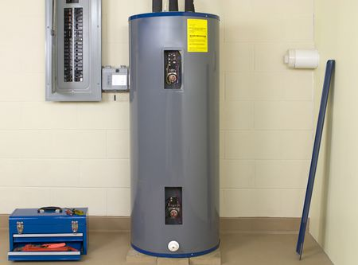

Standard Electric Water Heater On-Demand Electric Water
Heater

Technician Instructions and Recommendations:
- Have you discussed Plumbing Whole Home Maintenance with the customer?
- Does the Customer fully understand how to prevent this failure in the future?
- Review the 5 Year Plumbing Repair Guarantee and Customer Invoice
- Take time to explain options, educate, up-front price/approval, and our 5 Yr Guarantee

2

Gas Water Heaters

What Happened?
- Age of Water Heater (Life Cycle/Warranty)
- Leaking May Have Occurred
- Anode Rod Deterioration – Hard Water
- Sediment Build-up Reduces Life

Plumbing Technician Solutions
- Drain, Replace Anode Rod add USA PLUMBING Coverage
- Replacement of Unit
These are the internals of your Gas Water Heater unit.

It can be repaired or replaced.

With Proper Preventative Maintenance a crisis failure may be avoided saving you money and frustration.
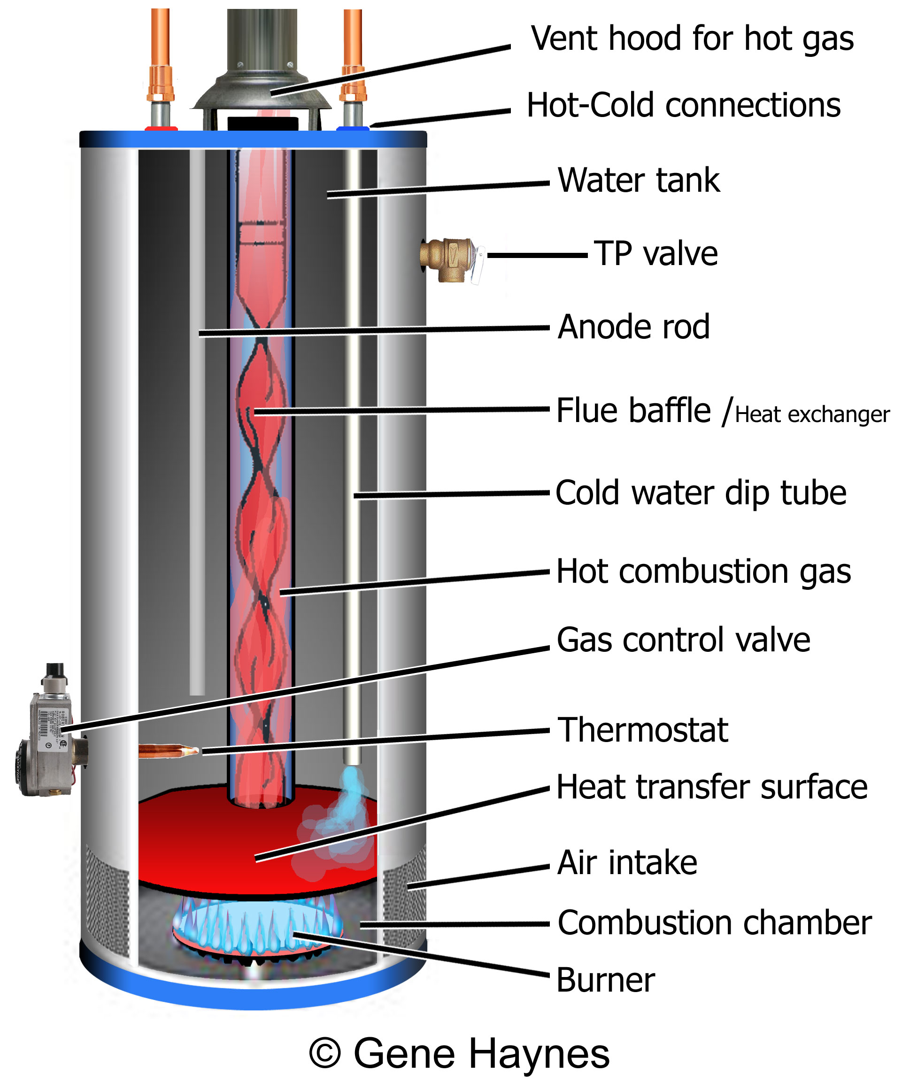

Technician Instructions and Recommendations:
- Have you discussed Plumbing Whole Home Maintenance with the customer?
- Does the Customer fully understand how to prevent this failure in the future?
- Review the 5 Year Plumbing Repair Guarantee and Customer Invoice
- Take time to explain options, educate, up-front price/approval, and our 5 Yr Guarantee

3

Water Heater Accessories

What Happened?
- Age can deteriorate parts on water heater
- Adding accessories can improve water heater safety

Plumbing Technician Solutions
- Replace Failed Part add USA PLUMBING Coverage
- Discuss Options for Accessories

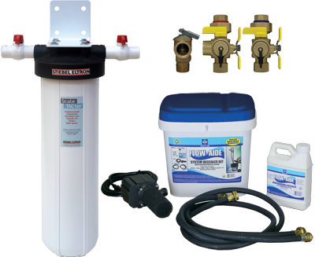

These are options.
It failed or can be added.

It can be replaced.

With Proper Preventative Maintenance a crisis failure may be avoided saving you money and frustration.

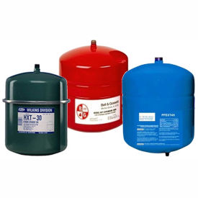

Technician Instructions and Recommendations:
- Have you discussed Plumbing Whole Home Maintenance with the customer?
- Does the Customer fully understand how to prevent this failure in the future?
- Review the 5 Year Plumbing Repair Guarantee and Customer Invoice
- Take time to explain options, educate, up-front price/approval, and our 5 Yr Guarantee

4

Exhaust Flue

What Happened?
- Corrosion
- Improperly Installed
- Not Current to New Plumbing Safety Code

Plumbing Technician Solutions
- Replace the Venting add USA PLUMBING Coverage
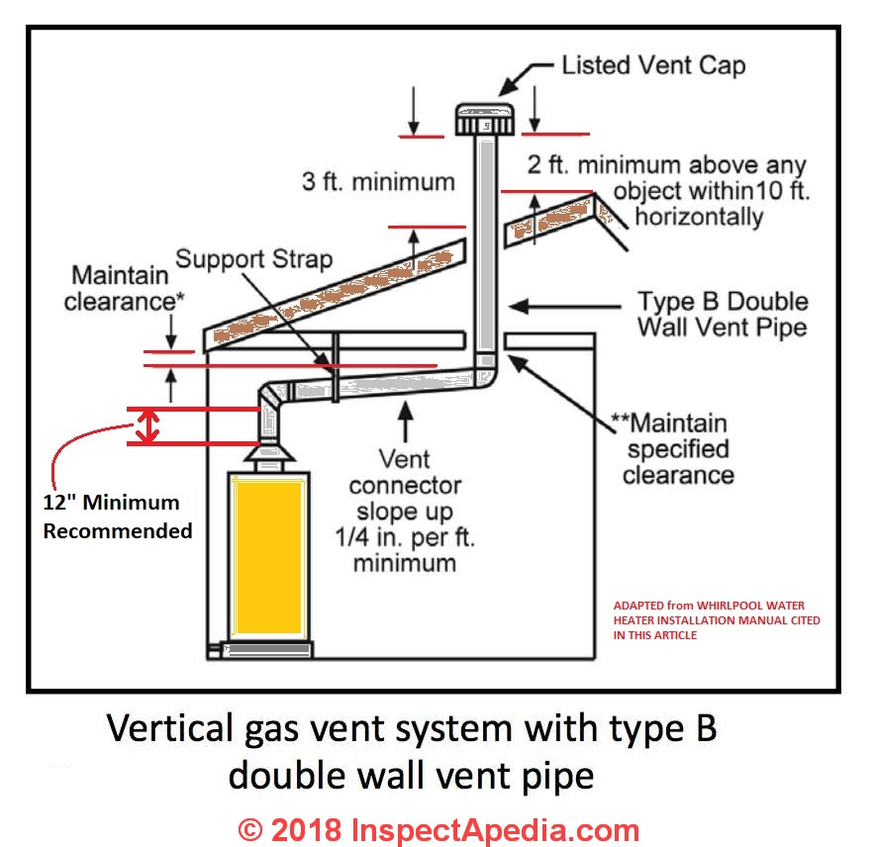
This is the Exhaust Vent
It may have a restriction or Failure in the air flow.

It can be repaired.

Below is Tankless Vent

With Proper Preventative Maintenance a crisis failure may be avoided saving you money and frustration.

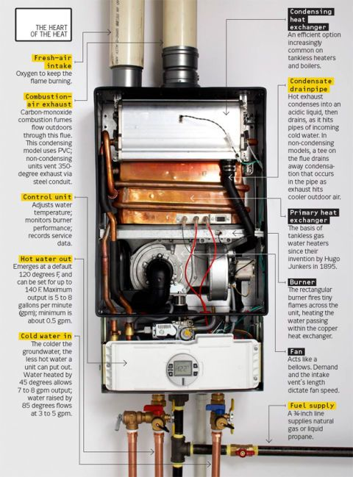

Technician Instructions and Recommendations:
- Have you discussed Plumbing Whole Home Maintenance with the customer?
- Does the Customer fully understand how to prevent this failure in the future?
- Review the 5 Year Plumbing Repair Guarantee and Customer Invoice
- Take time to explain options, educate, up-front price/approval, and our 5 Yr Guarantee

5

Water Closets (Toilets)

What Happened?
- Age of Part
- Water is Hard – Corrosion/Rust
- Deterioration – Water Treatment Chemicals
- Possible Clog – Materials/Drain Line

Plumbing Technician Solutions
- Replace the Failed Part add USA PLUMBING Coverage
- Option - Replacement of New Water Closet
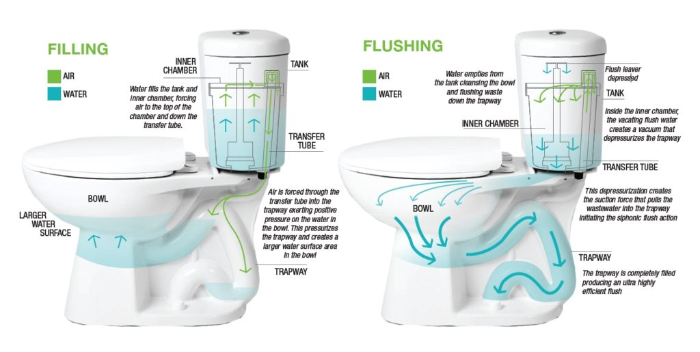

This is your Water Closet
A Part failed on your Toilet.

It can be repaired.

With Proper Preventative Maintenance a crisis failure may be avoided saving you money and frustration.

Technician Instructions and Recommendations:
- Have you discussed Plumbing Whole Home Maintenance with the customer?
- Does the Customer fully understand how to prevent this failure in the future?
- Review the 5 Year Plumbing Repair Guarantee and Customer Invoice
- Take time to explain options, educate, up-front price/approval, and our 5 Yr Guarantee

6

Water Closet Accessories

What Happened?
- Age of Part
- Options to Add Accessories

Plumbing Technician Solutions
- Replace-Add Part - Add USA PLUMBING Coverage
- Possible Addition of Accessories
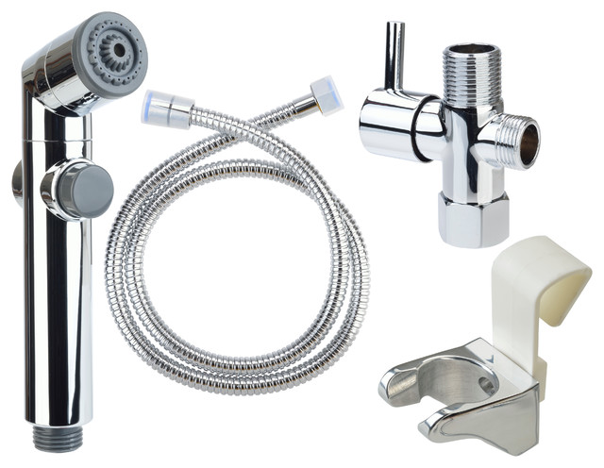

A part may have
failed on the Toilet.

It can be replaced. You may want to add a accessory?

With Proper Preventative Maintenance a crisis failure may be avoided saving you money and frustration.

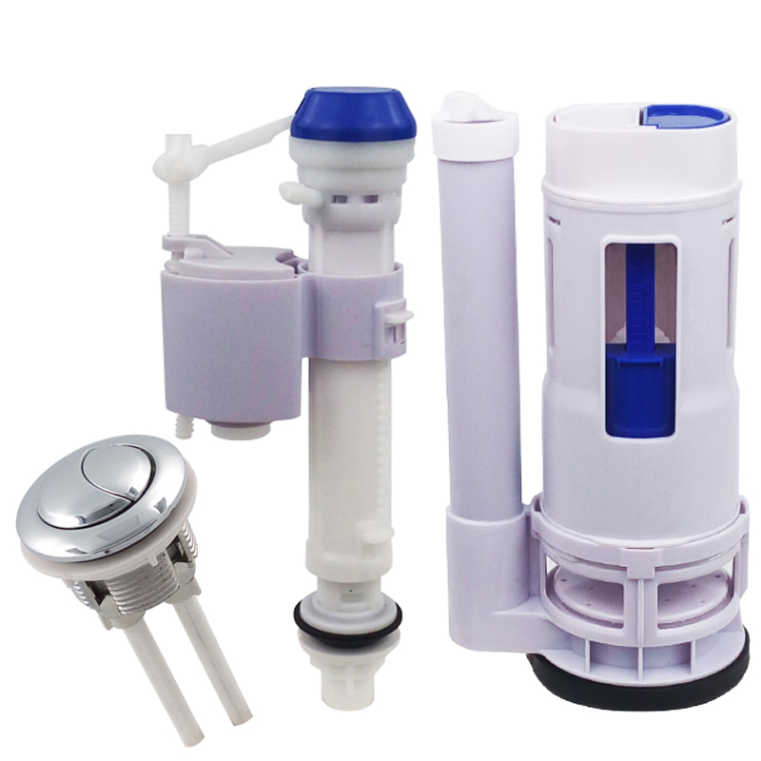

Technician Instructions and Recommendations:
- Have you discussed Plumbing Whole Home Maintenance with the customer?
- Does the Customer fully understand how to prevent this failure in the future?
- Review the 5 Year Plumbing Repair Guarantee and Customer Invoice
- Take time to explain options, educate, up-front price/approval, and our 5 Yr Guarantee

7

Disposals

What Happened?
- Age of Part Life Cycle
- Motor Failure
- Blades are Jammed
- Clogged or Material in System

Plumbing Technician Solutions
- Replace the Motor add USA PLUMBING Coverage
- Possible Replacement New Disposer
This is your garbage disposal.
It failed.

It can be replaced.

With Proper Preventative Maintenance a crisis failure may be avoided saving you money and frustration.
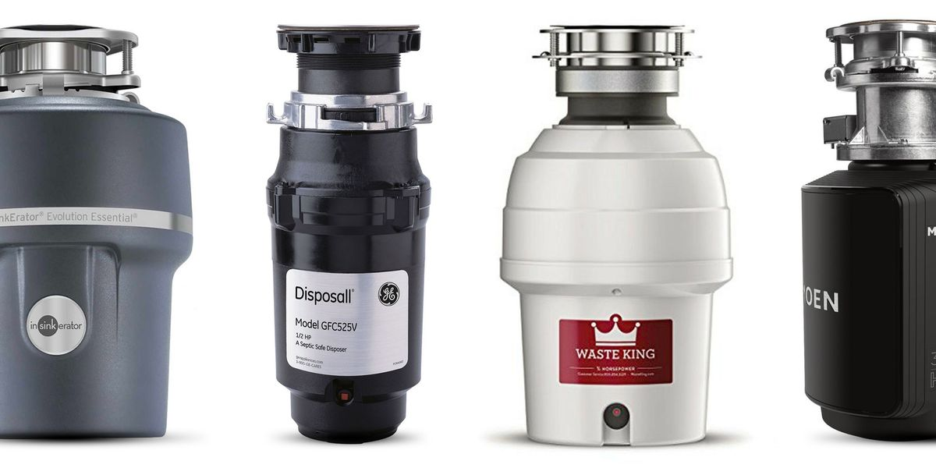

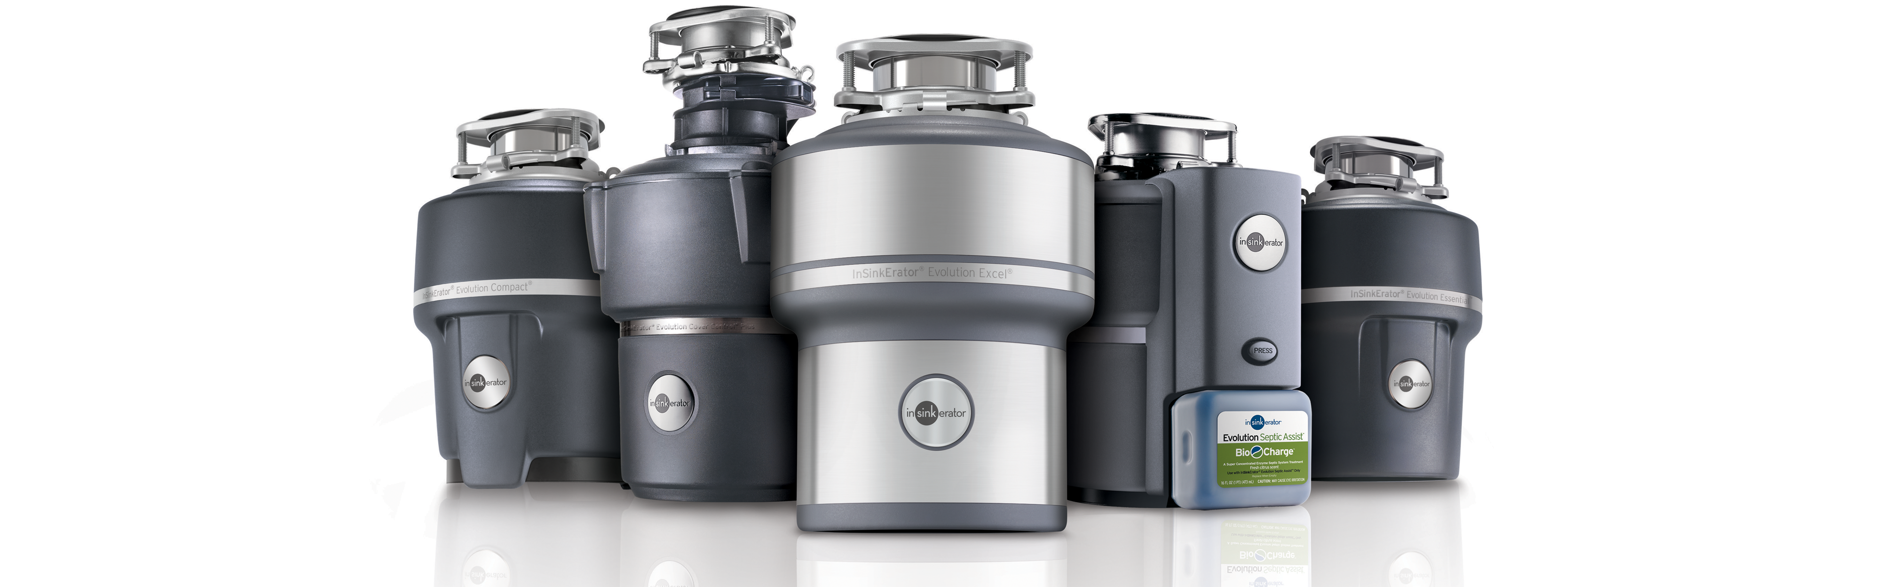

Technician Instructions and Recommendations:
- Have you discussed Plumbing Whole Home Maintenance with the customer?
- Does the Customer fully understand how to prevent this failure in the future?
- Review the 5 Year Plumbing Repair Guarantee and Customer Invoice
- Take time to explain options, educate, up-front price/approval, and our 5 Yr Guarantee

8

Faucet Replacement

What Happened?
- Age of Part – Life Cycle
- Leaking has Occurred
- Corrosion – Hard Water
- Deterioration – Wear and Tear

Plumbing Technician Solutions
- Replace the Faucet add USA PLUMBING Coverage

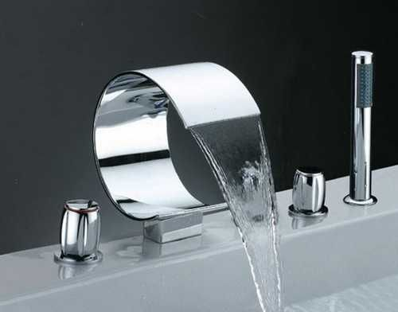

This is the Faucet.
It failed or is Deteriorating.

It can be replaced.

With Proper Preventative Maintenance a crisis failure may be avoided saving you money and frustration.

Technician Instructions and Recommendations:
- Have you discussed Plumbing Whole Home Maintenance with the customer?
- Does the Customer fully understand how to prevent this failure in the future?
- Review the 5 Year Plumbing Repair Guarantee and Customer Invoice
- Take time to explain options, educate, up-front price/approval, and our 5 Yr Guarantee

9

Faucet Repairs

What Happened?
- Age of Part – Life Cycle
- Leaking – Fittings/Washers/Pipes
- Corrosion - Deterioration

Plumbing Technician Solutions
- Repair the Part/Valve/Washers
- Replace the Faucet add USA PLUMBING Coverage

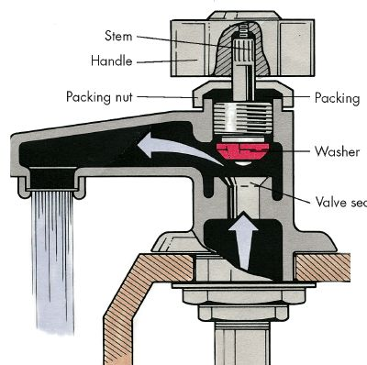

This is a Faucet
It has a failure.

It can be replaced.

With Proper Preventative Maintenance a crisis failure may be avoided saving you money and frustration.

Technician Instructions and Recommendations:
- Have you discussed Plumbing Whole Home Maintenance with the customer?
- Does the Customer fully understand how to prevent this failure in the future?
- Review the 5 Year Plumbing Repair Guarantee and Customer Invoice
- Take time to explain options, educate, up-front price/approval, and our 5 Yr Guarantee

10

Miscellaneous Fittings

What Happened?
- Age and Wear and Tear – Hard Water
- Residue has Built up
- Corrosion – Water Chemicals

Plumbing Technician Solutions
- Remove and clean
- Replace Fitting add USA PLUMBING Coverage
- Possible Replacement - Optional

These are Plumbing Fittings, time & Wear and Tear create failures.

It may need replaced.

With Proper Preventative Maintenance a crisis failure may be avoided saving you money and frustration.

Technician Instructions and Recommendations:
- Have you discussed Plumbing Whole Home Maintenance with the customer?
- Does the Customer fully understand how to prevent this failure in the future?
- Review the 5 Year Plumbing Repair Guarantee and Customer Invoice
- Take time to explain options, educate, up-front price/approval, and our 5 Yr Guarantee

11

Waste and Overflow

What Happened?
- Age and Wear and Tear
- Possible Motor/Pump Failure
- Back-up occurred – Debris, Hard Water

Plumbing Technician Solutions
- Replace the Pump/Motor add USA PLUMBING Coverage
- Possible Replacement of Unit
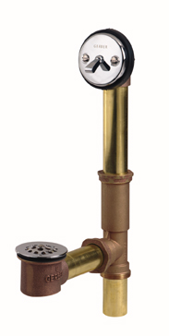

This is the Overflow System. It has failed.

It can be repaired.

With Proper Preventative Maintenance a crisis failure may be avoided saving you money and frustration.

Technician Instructions and Recommendations:
- Have you discussed Plumbing Whole Home Maintenance with the customer?
- Does the Customer fully understand how to prevent this failure in the future?
- Review the 5 Year Plumbing Repair Guarantee and Customer Invoice
- Take time to explain options, educate, up-front price/approval, and our 5 Yr Guarantee

12

Miscellaneous Repairs

What Happened?
- Age of Part – Basic Wear and Tear
- Corrosion-Back-up, Fatigued Metal

Plumbing Technician Solutions
- Replace the Failed Part add USA PLUMBING Coverage
- Possible Replacement of Unit
- Upgrade – Add Water Filtration (Warranty, Future Repairs)

A Plumbing part has experienced failure.

It can be repaired.

With Proper Preventative Maintenance a crisis failure may be avoided saving you money and frustration.

Technician Instructions and Recommendations:
- Have you discussed Plumbing Whole Home Maintenance with the customer?
- Does the Customer fully understand how to prevent this failure in the future?
- Review the 5 Year Plumbing Repair Guarantee and Customer Invoice
- Take time to explain options, educate, up-front price/approval, and our 5 Yr Guarantee

13

Back Flow Preventers

What Happened?
- Age of Part – Wear and Tear - Weather
- Restriction in Line Causes Blockages

Plumbing Technician Solutions
- Replace the failed part add USA PLUMBING Coverage
- Possible Replacement of Valve and New Unit
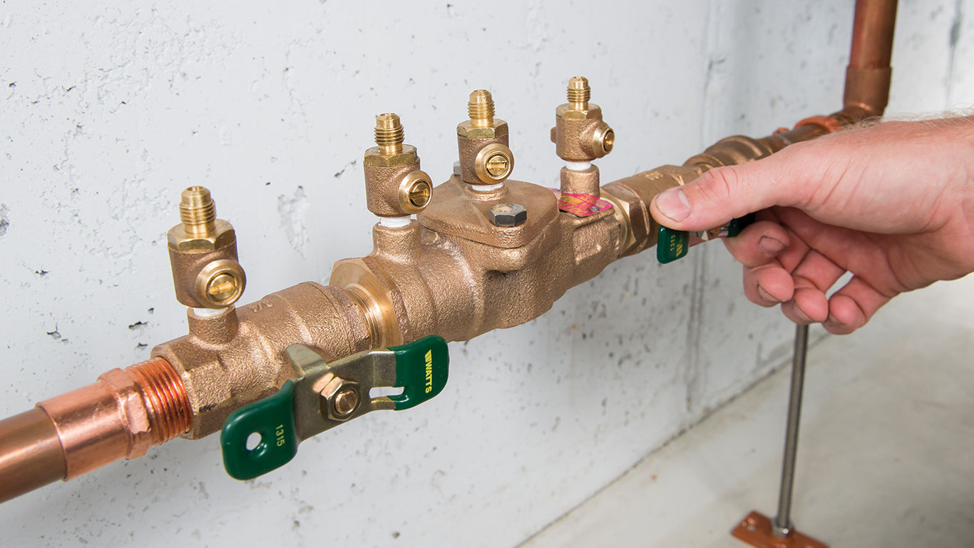
This is the backflow preventer, it protects the water from backing into potable supply.

It can be replaced.

With Proper Preventative Maintenance a crisis failure may be avoided saving you money and frustration.

Technician Instructions and Recommendations:
- Have you discussed Plumbing Whole Home Maintenance with the customer?
- Does the Customer fully understand how to prevent this failure in the future?
- Review the 5 Year Plumbing Repair Guarantee and Customer Invoice
- Take time to explain options, educate, up-front price/approval, and our 5 Yr Guarantee

14

Natural Gas Piping

What Happened?
- Wear and Tear over time – Seal Expansion/Contraction
- Leaks from age/temperature/movement
- Need New Installation/Remodel Changes

Plumbing Technician Solutions
- Fix all leaks, Repairs to Gas Piping, New Lines, Test
- Repair Gas Line add USA PLUMBING Coverage
- Possible Replacement of Gas Appliance

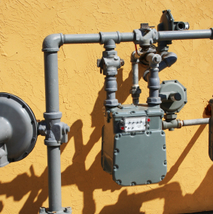
Gas Piping can leak. It has to be properly repaired & tested.

It can be repaired.

With Proper Preventative Maintenance a crisis failure may be avoided saving you money and frustration.

Technician Instructions and Recommendations:
- Have you discussed Plumbing Whole Home Maintenance with the customer?
- Does the Customer fully understand how to prevent this failure in the future?
- Review the 5 Year Plumbing Repair Guarantee and Customer Invoice
- Take time to explain options, educate, up-front price/approval, and our 5 Yr Guarantee

15

Outside Piping Repairs

What Happened?
- Age – Roots Invade
- Crack in Pipes – Wear and Tear
- Severe Weather Can Damage Pipes

Plumbing Technician Solutions
- Identify Clog/Leak with Camera
- Identify Pipe Issues and Repair
- Repair Lines - Jett/Snake the Lines – Power add USA PLUMBING Coverage
- Possible Replacement of Line-(Re-pipe or New)

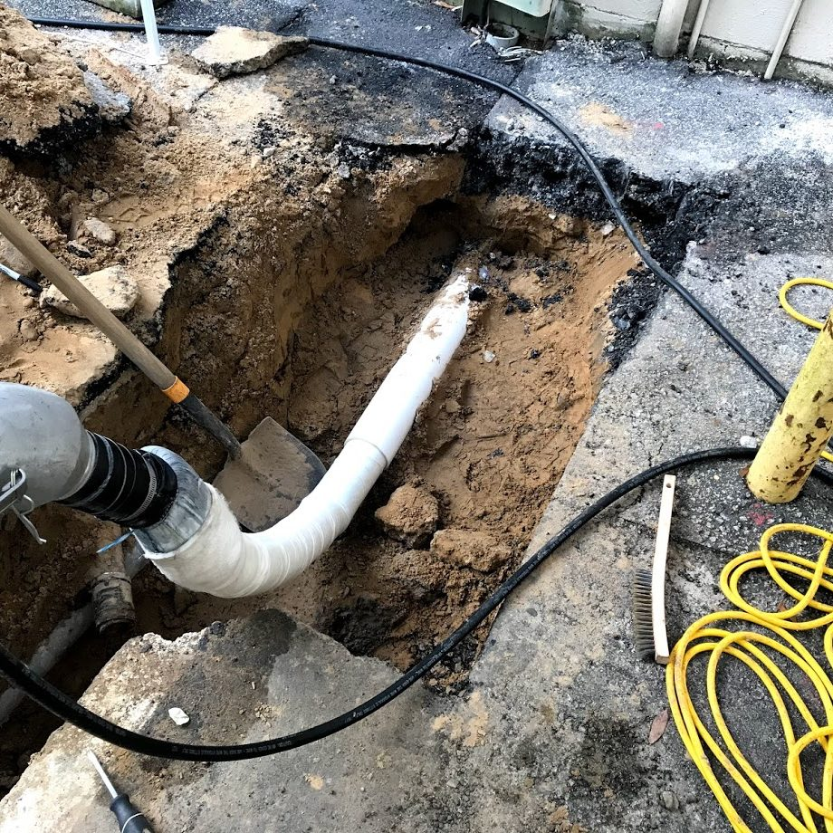

This is a Drain Line System. It has a failure.

It can be replaced.

With Proper Preventative Maintenance a crisis failure may be avoided saving you money and frustration.

Technician Instructions and Recommendations:
- Have you discussed Plumbing Whole Home Maintenance with the customer?
- Does the Customer fully understand how to prevent this failure in the future?
- Review the 5 Year Plumbing Repair Guarantee and Customer Invoice
- Take time to explain options, educate, up-front price/approval, and our 5 Yr Guarantee

16

Miscellaneous Pipe Repairs

What Happened?
- Pipes Indoor and Outdoor, may get Damaged by Wear and Tear, Age

- Poor Weather

Plumbing Technician Solutions
- Replace the Piping
- Re-Pipe Option

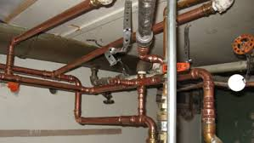
The Drain lines or piping inside or out can break, needing repairs.

It can be repaired.

With Proper Preventative Maintenance a crisis failure may be avoided saving you money and frustration.

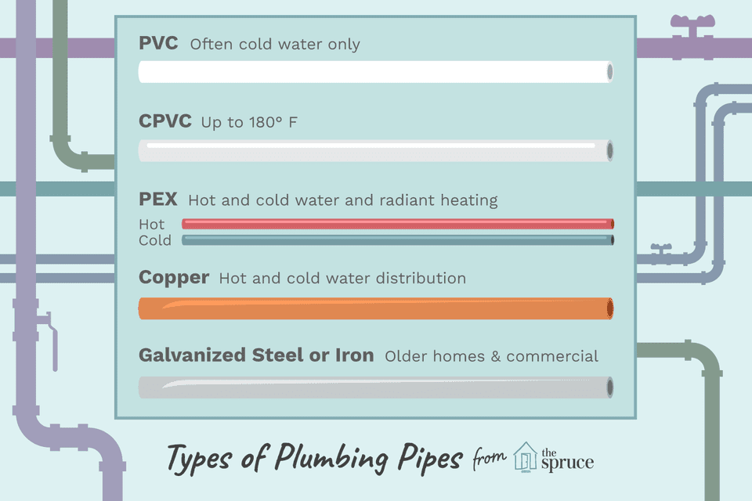

Technician Instructions and Recommendations:
- Have you discussed Plumbing Whole Home Maintenance with the customer?
- Does the Customer fully understand how to prevent this failure in the future?
- Review the 5 Year Plumbing Repair Guarantee and Customer Invoice
- Take time to explain options, educate, up-front price/approval, and our 5 Yr Guarantee

17

Equipment Rental Daily

What Happened?
- Some Repairs Require Daily Equipment Rental

Plumbing Technician Solutions
- Advise Homeowner
- Approval for Up-Front Pricing to Conduct Work
- Effect Repairs and add USA PLUMBING Coverage

This style heavy equipment is sometimes needed (rented) to complete the work.

It can be replaced.

With Proper Preventative Maintenance a crisis failure may be avoided saving you money and frustration.

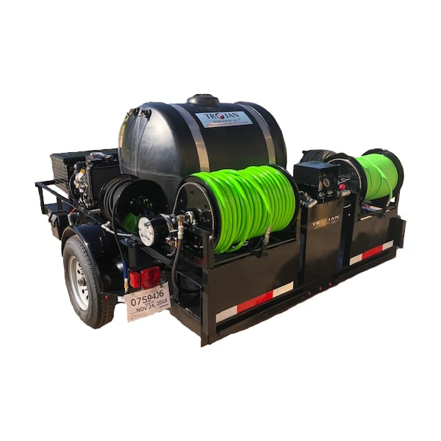

Technician Instructions and Recommendations:
- Have you discussed Plumbing Whole Home Maintenance with the customer?
- Does the Customer fully understand how to prevent this failure in the future?
- Review the 5 Year Plumbing Repair Guarantee and Customer Invoice
- Take time to explain options, educate, up-front price/approval, and our 5 Yr Guarantee

18

Drain Line Stoppages

What Happened?
- Age of Drain Lines
- Severe Weather Patterns Can Damage Lines
- Corrosion, Issues with Water

Plumbing Technician Solutions
- Unclog the Drain Line Stoppage
- Repair or Replace the Drain Line
- Re-Pipe as an option add USA PLUMBING Coverage

Drain Lines can often clog or fail for many reasons.

It can be repaired or replaced.

With Proper Preventative Maintenance a crisis failure may be avoided saving you money and frustration.
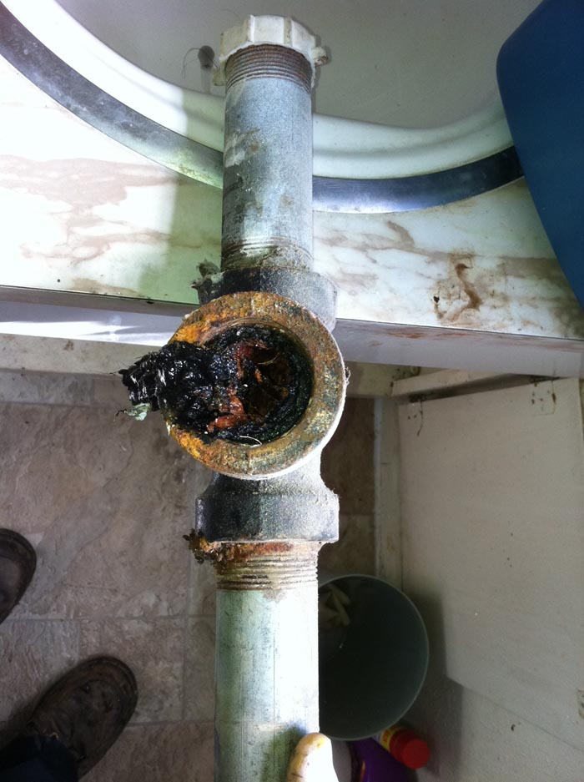

Technician Instructions and Recommendations:
- Have you discussed Plumbing Whole Home Maintenance with the customer?
- Does the Customer fully understand how to prevent this failure in the future?
- Review the 5 Year Plumbing Repair Guarantee and Customer Invoice
- Take time to explain options, educate, up-front price/approval, and our 5 Yr Guarantee

Sewer & Drains Miscellaneous

19

What Happened?
- Age and Deterioration
- Significant Clogs/Roots/Cracked Lines
- Excess Debris

Plumbing Technician Solutions
- Repair and Unclog Drain (Jetter/Snake)
- Replace the Drain Line add USA PLUMBING Coverage
- Possible Re-Pipe
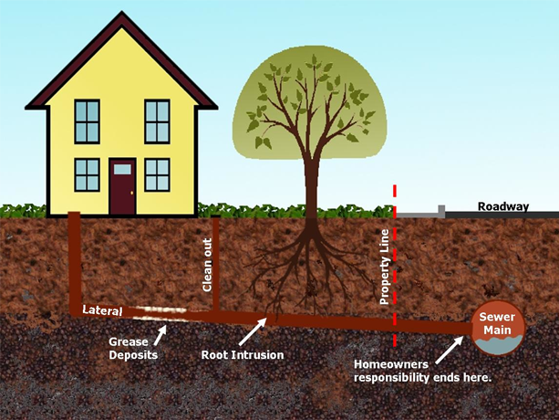
Sewer and Drains can fail for a variety of reasons. Cracks and roots are most common.

It can be replaced.

With Proper Preventative Maintenance a crisis failure may be avoided saving you money and frustration.

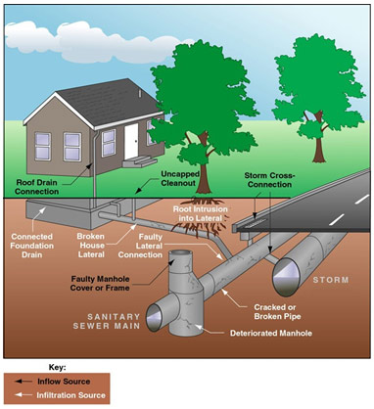

Technician Instructions and Recommendations:
- Have you discussed Plumbing Whole Home Maintenance with the customer?
- Does the Customer fully understand how to prevent this failure in the future?
- Review the 5 Year Plumbing Repair Guarantee and Customer Invoice
- Take time to explain options, educate, up-front price/approval, and our 5 Yr Guarantee

Drain Line Repairs

20

What Happened?
- Age of Drain Line or Piping
- Dirt/Debris
- Severe Weather Impact on Drain/Sewer

Plumbing Technician Solutions
- Clean the Drain Line add USA PLUMBING Coverage
- Replace the Cracked Drain Line
- Possible Re-Pipe of Drain Line
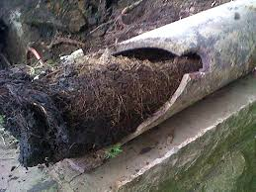

Drain failures can occur, clogs, roots, cracks for variety of reasons.

It can be replaced.

With Proper Preventative Maintenance a crisis failure may be avoided saving you money and frustration.

Technician Instructions and Recommendations:
- Have you discussed Plumbing Whole Home Maintenance with the customer?
- Does the Customer fully understand how to prevent this failure in the future?
- Review the 5 Year Plumbing Repair Guarantee and Customer Invoice
- Take time to explain options, educate, up-front price/approval, and our 5 Yr Guarantee

Pumps & Accessories

21

What Happened?
- Age of Part – Motor/Pump
- Dirt and Debris – stressed motor/Pump
- Worn motor bearings, debris in Pump

Plumbing Technician Solutions
- Replace the Motor/Pump add USA PLUMBING Coverage
- Possible Replacement of Sump Pump
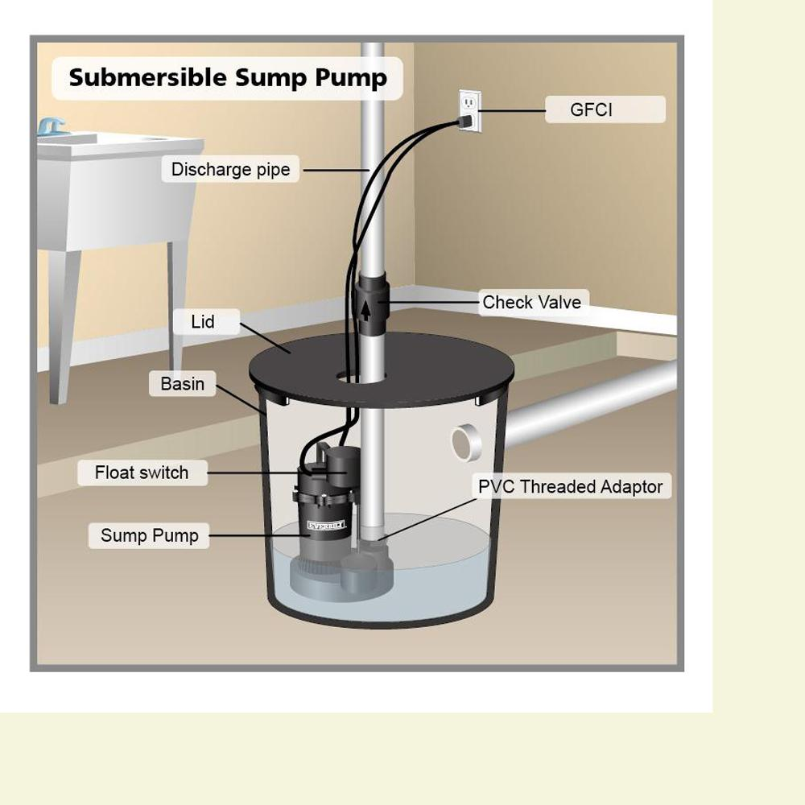

This is the Sump Pump.
It failed and protects homes drainage system.

It can be repaired.

With Proper Preventative Maintenance a crisis failure may be avoided saving you money and frustration.

Technician Instructions and Recommendations:
- Have you discussed Plumbing Whole Home Maintenance with the customer?
- Does the Customer fully understand how to prevent this failure in the future?
- Review the 5 Year Plumbing Repair Guarantee and Customer Invoice
- Take time to explain options, educate, up-front price/approval, and our 5 Yr Guarantee

Water Softening Systems

22

What Happened?
- Part failed Wear and Tear- Age
- Rust or Corrosion – Extremely Hard Water

Plumbing Technician Solutions
- Discuss Options - Repair the Softener
- Possible Replacement-Upgrade Water Softener

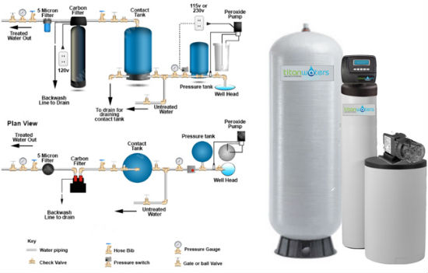

This is your Water Softener.
It has a failure.

They can be replaced.

With Proper Preventative Maintenance a crisis failure may be avoided saving you money and frustration.

Technician Instructions and Recommendations:
- Have you discussed Plumbing Whole Home Maintenance with the customer?
- Does the Customer fully understand how to prevent this failure in the future?
- Review the 5 Year Plumbing Repair Guarantee and Customer Invoice
- Take time to explain options, educate, up-front price/approval, and our 5 Yr Guarantee

Water Filtration

23

What Happened?
- Filtration System Failure – Wear and Tear – Age
- Failure of Filtering Apparatus

Plumbing Technician Solutions
- Replace the Filtering Apparatus add USA PLUMBING Coverage
- Possible Replacement of Filtration(Age-Warranty?)
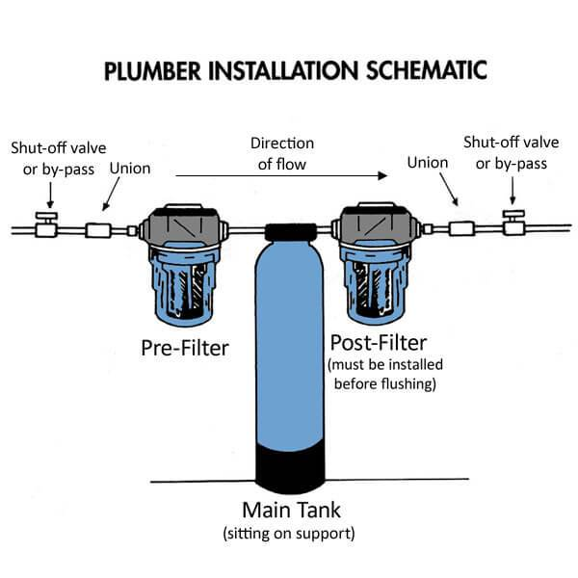

This is homes filtration system.
It experienced a failure.

It can be replaced.

With Proper Preventative Maintenance a crisis failure may be avoided saving you money and frustration.

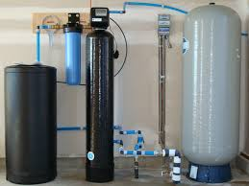

Technician Instructions and Recommendations:
- Have you discussed Plumbing Whole Home Maintenance with the customer?
- Does the Customer fully understand how to prevent this failure in the future?
- Review the 5 Year Plumbing Repair Guarantee and Customer Invoice
- Take time to explain options, educate, up-front price/approval, and our 5 Yr Guarantee

